Making a prayer board

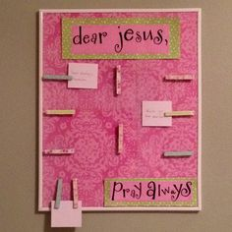

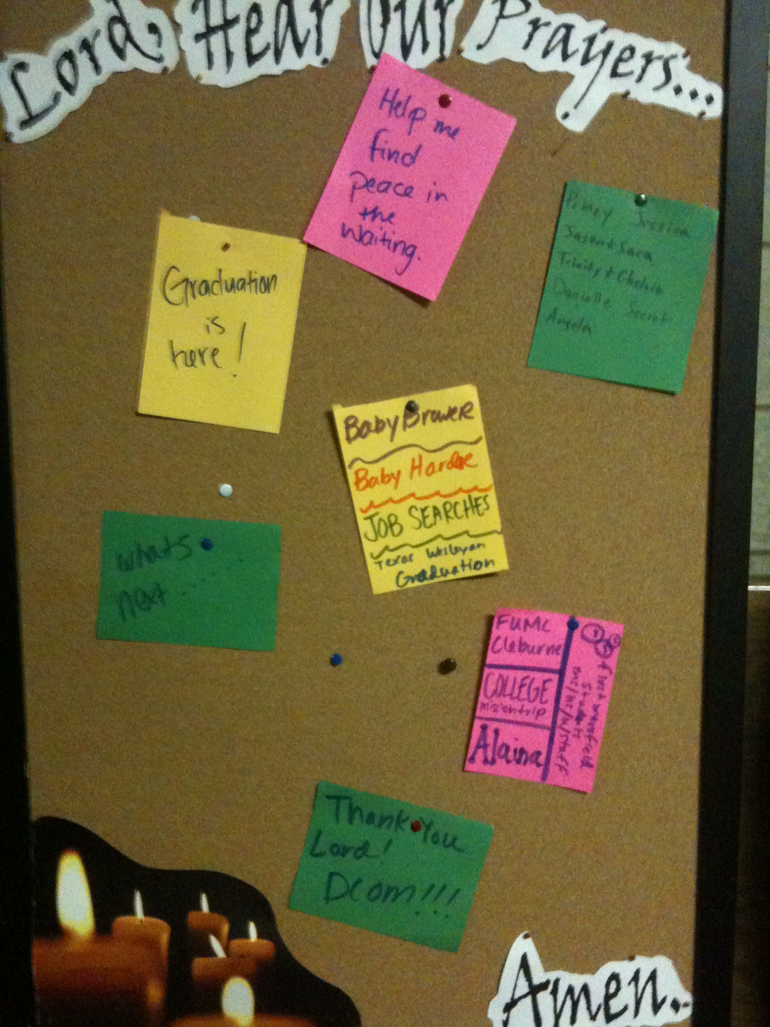

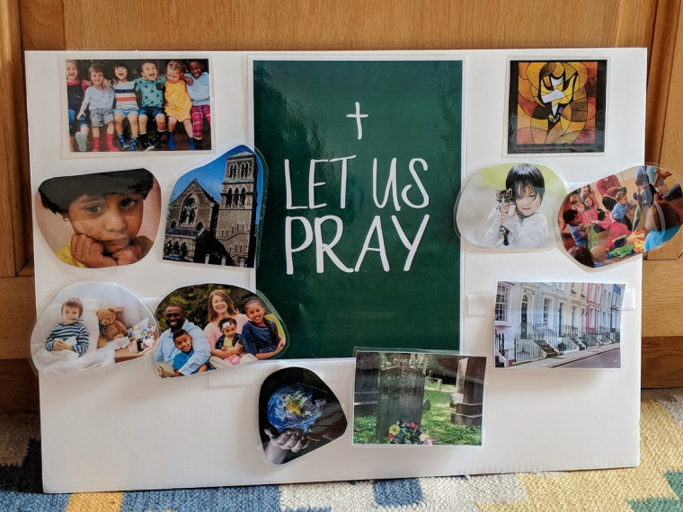

A prayer board is a daily reminder to pray for those in need, those we love, and things we are passionate about.

**You will need:**

A piece of card for your board (you could use old cereal packet or box).

Images from internet, magazines, postcards, greeting cards or you could draw them yourself.

Note cards, post it notes or paper to write the requests and Bible verses.

Pens or markers (gel pens are good to add some colour to the board).

Bible or computer (Bible Gateway.com is fabulous for a quick topical verse search).

Velcro if you have some or blue tack.

Scissors.

Pritt stick

If you have a laminator you could laminate our pictures.

**Younger children and Toddlers**

Toddlers and little ones may have little patience for sitting still and listening to wordy prayers. Using pictures and movement, we can help them connect to God through prayer in a way that works with natural toddler-ness instead of against it.

Toddler’s love choosing things, and they love sticking things onto boards with velcro. And the ones who are in Nursery or Reception are probably doing lots of this during the week, so they already know how it works!

**Older children and teenagers**.

You might like to use a mixture of pictures, words, bible verses or write your own prayers. (See sheet on of prayer labels 1) you might like to print them out and use on your board.

**Here are some ideas**.

USING “LET US PRAY” as the centre image, helps to teach us the language we use in church every week. You could use “PRAYER BOARD” or “TIME TO TALK TO GOD” or any number of things.

1. A church (You could choose a picture of our own church, which the children would recognise).
2. A family (It could be one with your immediate family or one that includes grandparents and extended family).
3. A group of children playing.
4. A child looking sad.
5. A child holding a pet.
6. The earth.
7. A row of houses (you could use your own street/road)
8. A child in bed with a thermometer in their mouth and a teddy bear.
9. A gravestone with flowers on it.

For each image, here are one or two sentences to go with it: (on separate sheet too).

1. We pray for our church, ……… Help us to know you here and everywhere.
2. We pray for our families. Help us to take care of each other.
3. We pray for our friends and teachers and schools and nurseries and toddler groups.
4. Help everyone who is sad or lonely or scared.
5. We pray for our pets and all the animals.
6. We pray for everything in the whole wide world and universe.
7. We pray for our homes. Make them places where everyone is safe and loved.
8. We pray for everyone who is ill or feeling poorly.
9. We pray for people and animals who have died. We miss them even though we know they are safe in heaven with you.

**For younger Children**

Print out the images or (find in magazines or draw) print or write out prayers, cut them out, and stick the prayers on the back of each image. If you have a laminater you could laminate them but it doesn’t matter.

Get your piece of card/board or what you are going to use as your background. Cover, paint or leave as it is your choice and then if you have velcro large strips might be better than dots. Very small children might not have the hand-eye coordination to match up small dots of velcro. You could use blue tack

If using velcro stick the other side of the velcro to the backs of the laminated images, and we were done!

**How to use it:**

You could put all the images in a drawstring bag, and bring it out with “I wonder what’s in here … !” Under-5s love seeing what’s in the bag/box/etc. They can then choose one to put up, hand it to the leader, who reads the prayer on the back, and hands it back to the child to put on the board. You may want to only chose a couple or so as children’s attention can be short. That’s ok.

If you use the same closing words every time, such as “Lord, in your mercy / Hear our prayer,” you may want to add those to your board.

**Older children and teenagers.**

You can use pictures (as above to put on your board) also write prayers on a variety of different papers, cards or sticky notes. Bible verses are good to put on your board which you can pray over. You could attach your prayers using string, cord or ribbon and pegs. As a family you could spend some time praying for what is on your prayer board. Also use some of your time to pray on your own over your prayers.

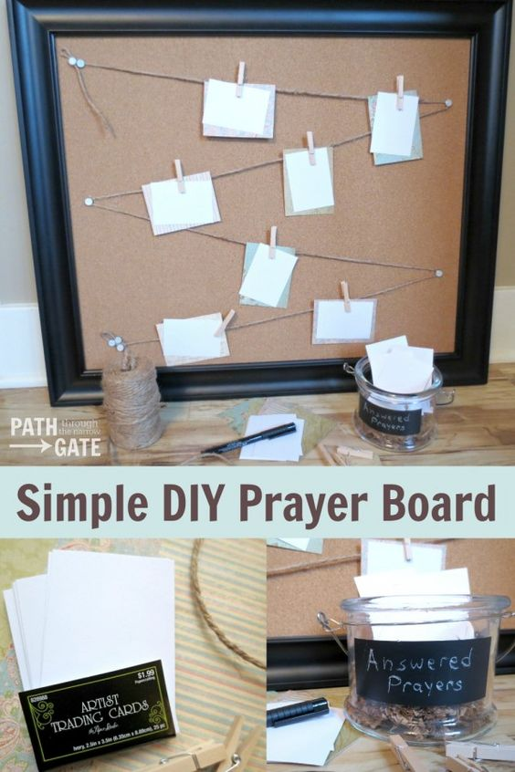

Hope you have fun making your prayer board and helps you to pray.

Jane

I would love to see what you have made :-)

Adapted from an idea by Children’s ministry in St. Alban’s Diocese.

Pictures from Google and Pinterest.