- The people who stood at a distance
Read Luke 23:44-49
Social distancing at the crucifixion….

There are a number of reasons why Jesus’ acquaintances might have stood at distance….
It was too painful to watch from close up….
They were fearful of being associated with him….
Women were always at the back of the crowd….

How close to the cross are you standing?
What can you see from where you are? What can you hear?
Who is standing with you? Who is standing at a distance from you?

Romans 8:35-39 feels particularly appropriate for funerals at the moment as even the few who are able to be present have to sit two metres apart. Perhaps there is someone you could share these words with this week?

If you have internet you might like to listen to the Taizé chant based on this passage. It is sung in different languages - reminding us that people around the world are standing together at the foot of the cross this week.

https://www.youtube.com/watch?v=Qb4GZv8I0f8
Reading the Holy Week story with Covid -19 eyes

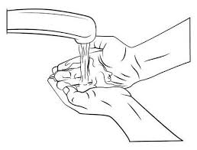

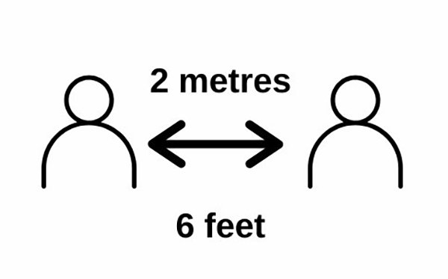

- The woman with her precious ointment.

Read John 12:1-11

If this woman were offering her precious gift today, she would probably be presenting Jesus with a large bottle of antibacterial hand gel! Judas would criticize her for not selling it on e-Bay for a much higher price than she had bought it for. Others would be angry about her selfish stockpiling and would want to know whether she also had toilet paper or pasta hidden away in a secret stash somewhere.

Jesus recognised that she was giving him in advance the loving physical touch that she would want to offer as he died or when he was buried. The Covid-19 social distancing rules would prevent her from being present at his death and at his funeral.
What can you offer someone today that you might not be able to offer tomorrow?
Pray these words by reading or singing them:
Take my love; my Lord, I pour at Thy feet its treasure store.
Take myself, and I will be ever, only, all for Thee.

If you have internet, you can click on this link for a meditative version of the other verses.
https://www.youtube.com/watch?v=6QubPnYFavY
- The man who washed his hands
Read Matthew 27:15-26

We all know how important it is to wash our hands frequently to prevent infection, but did you know that saying the Lord’s Prayer takes the same amount of time as singing “Happy Birthday to you” twice?!

Pilate washes his hands to show that he is not responsible for the death of Jesus. We still use the phrase “to wash our hands of someone or something” today when we want to reject or deny our involvement.

When have you washed your hands of someone or something?
What sins do you need Jesus to wash away this Holy Week?

You might like to read Psalm 51.
If you have internet you can watch this beautiful musical setting of it https://www.youtube.com/watch?v=fcWo1hKHu40
You could also watch this recording of Judi Dench washing her hands as she plays Lady Macbeth, deeply troubled by her involvement in the assassination of King Duncan
https://www.youtube.com/watch?v=9dgbbtUbgcM

